**CSA1195 OBJECT ORIENTED ANALYSIS AND DESIGN**

**DAY 4 LAB PRACTICAL : 11.08.2023**

**NAME : P.GUNADEESH REDDY**

**REGISTER NUMBER : 192111198**

**1.** **Develop a system using UML for Library Management System. It should verify the details of the reader by the central computer. The details regarding the reader will be provided to the central computer through the administrator in the library and the computer will verify the details of the reader and provide approval to the office. Then the books that are needed by the reader will issue from the library to him.**

**USE CASE DIAGRAM:**

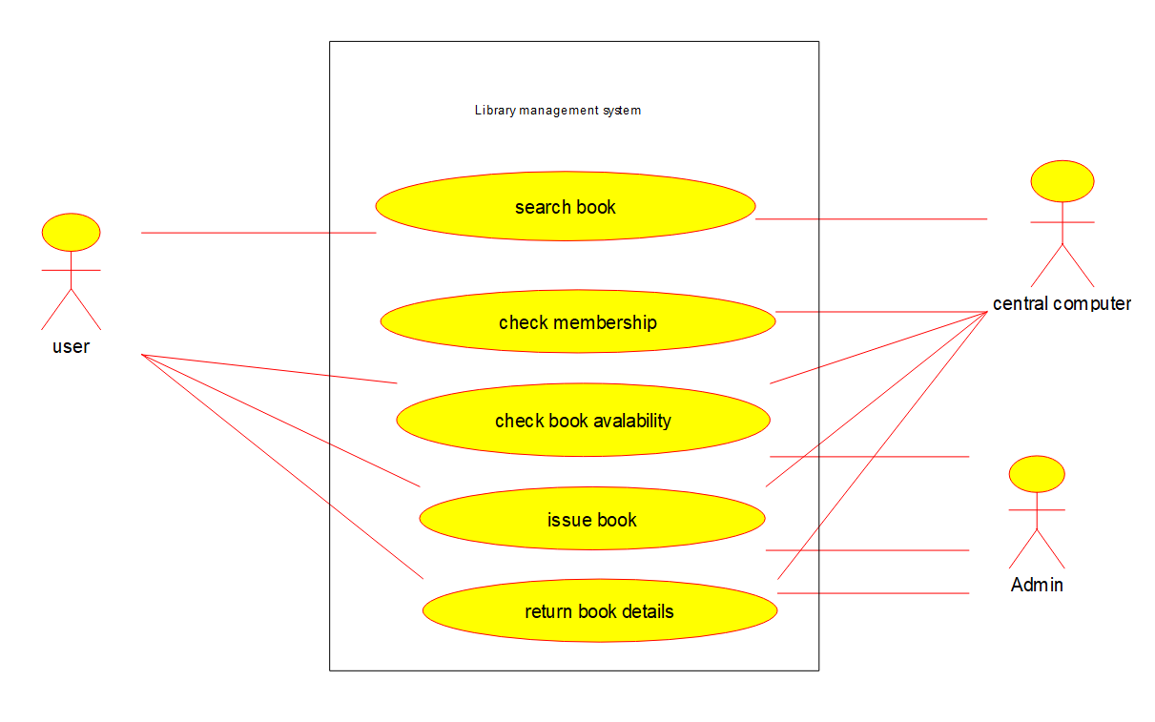

**CLASS DIAGRAM:**

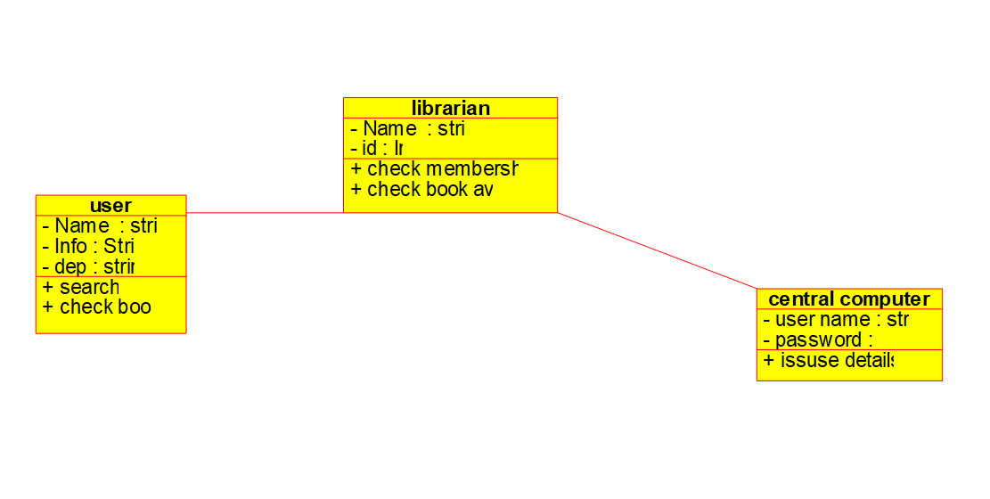

**ACTIVITY DIAGRAM:**

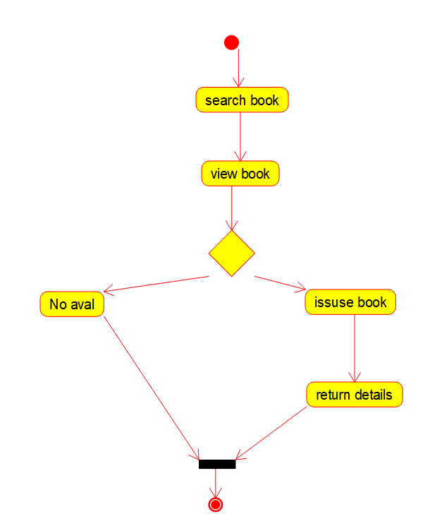

**SEQUENCE DIAGRAM:**

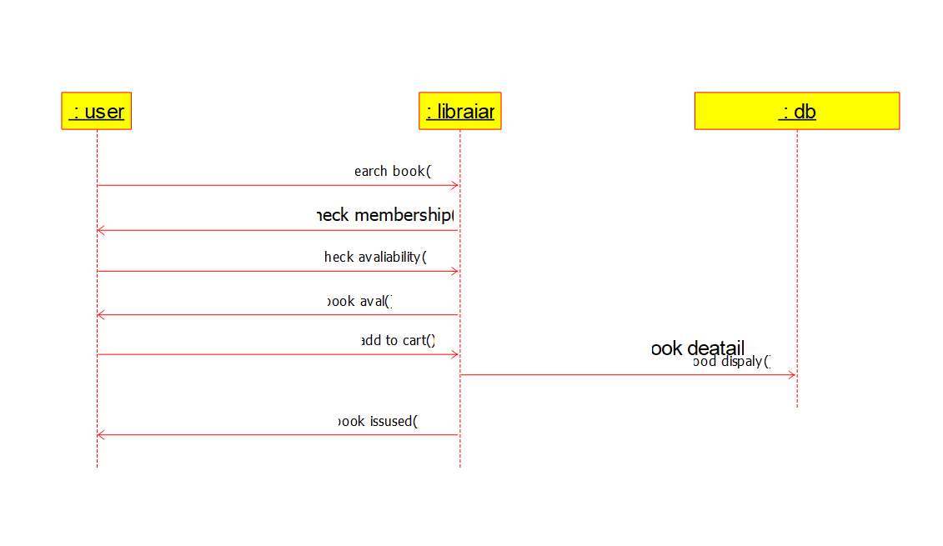

**COMPONENT DIAGRAM:**

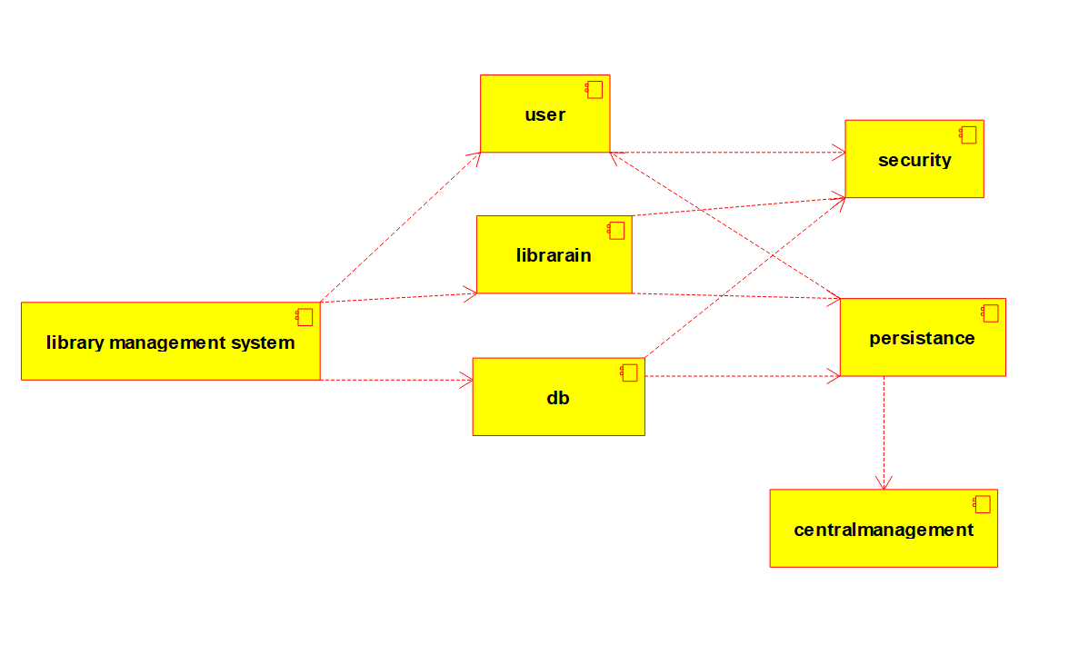

**COLLABORATION DIAGRAM:**

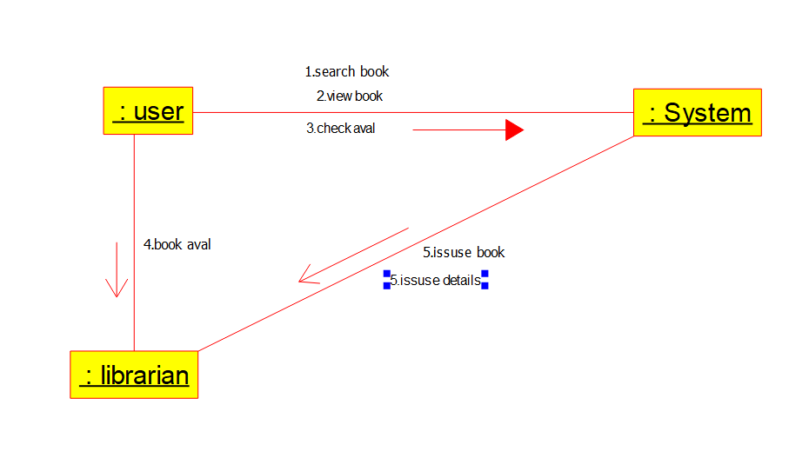

**DEPLOYMENT DIAGRAM:**

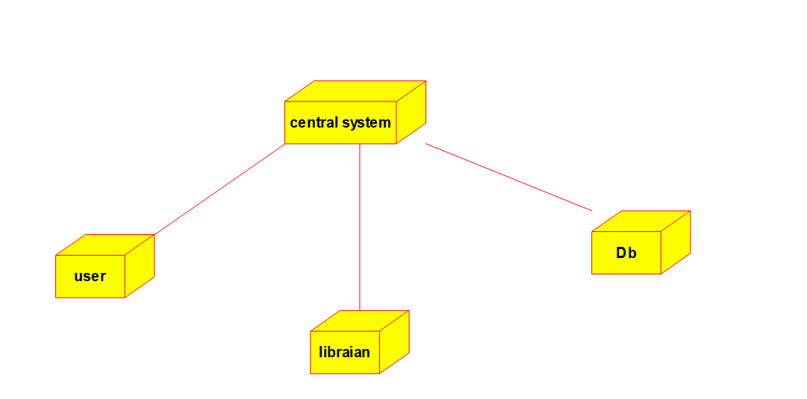

**STATE DIAGRAM:**

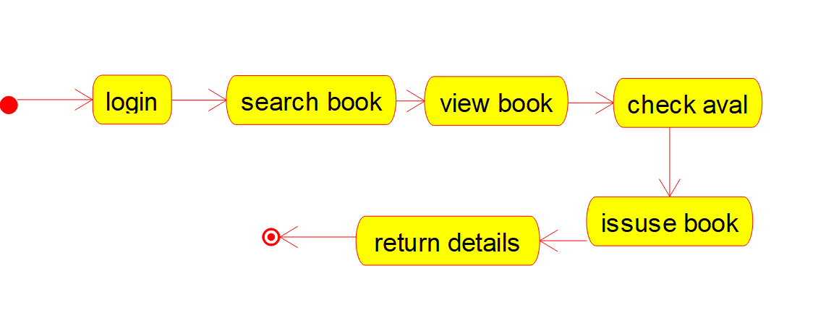

**ER DIAGRAM:**

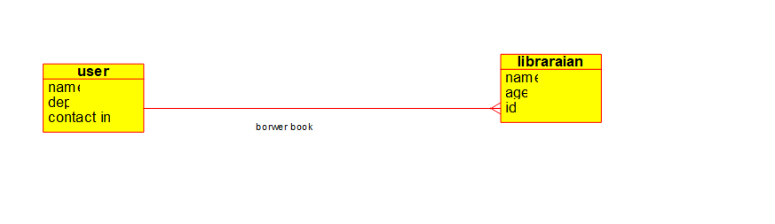

**2.Develop a system using UML for Online Voting System. Registration of the new citizen and update can be done in the system. The process of initiating the polling. The voting was done from the citizen’s end and the result publishing should be maintained by the admin.**

**USE CASE DIAGRAM:**

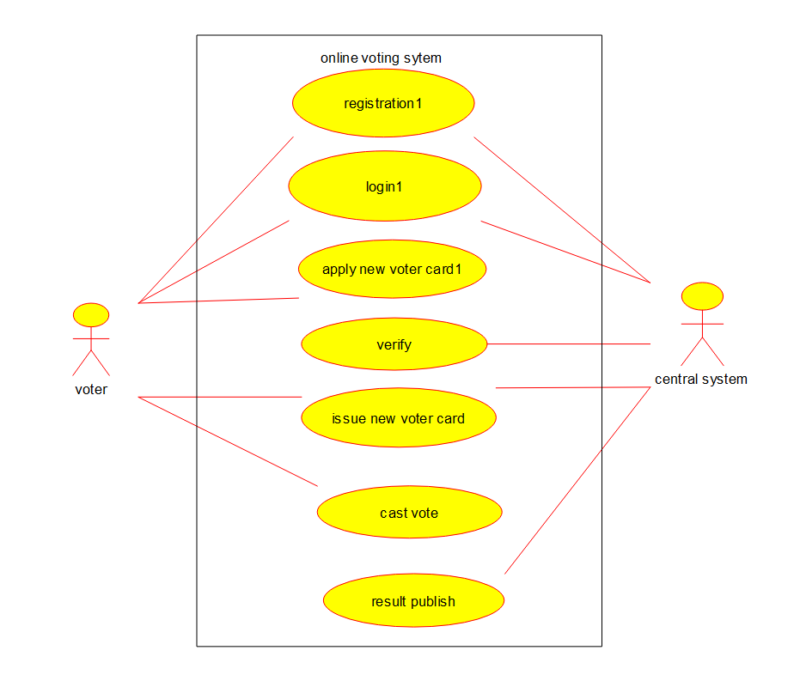

**CLASS DIAGRAM:**

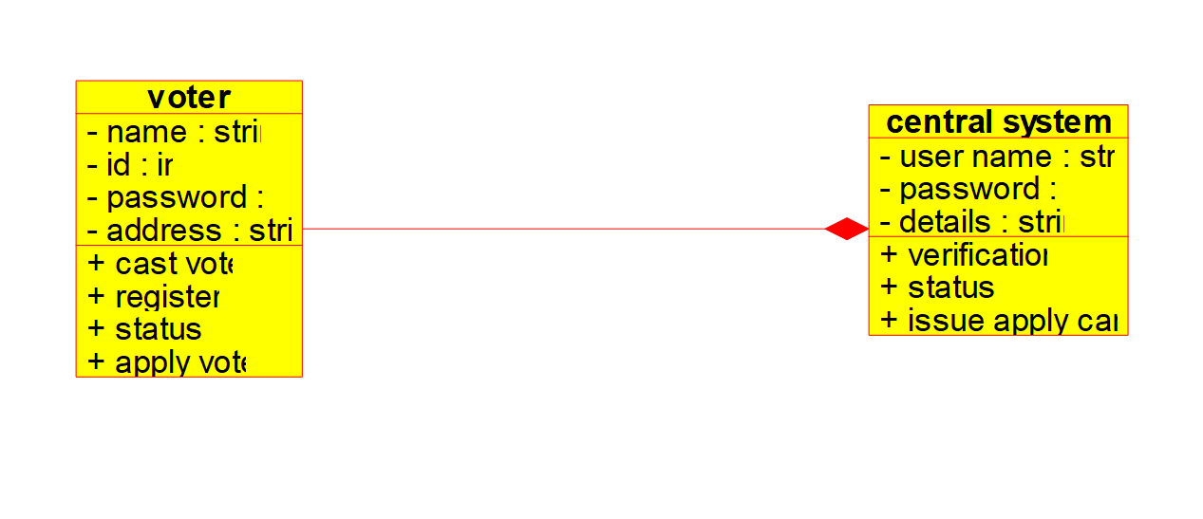

**ACTIVITY DIAGRAM:**

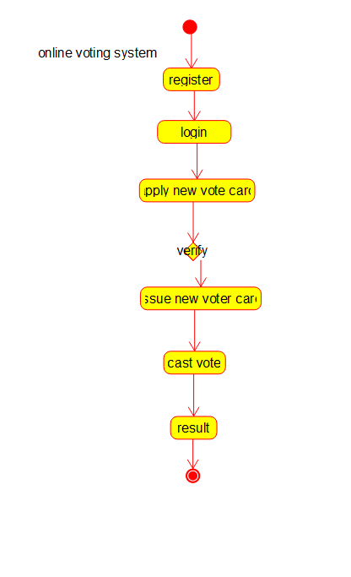

**SEQUENCE DIAGRAM:**

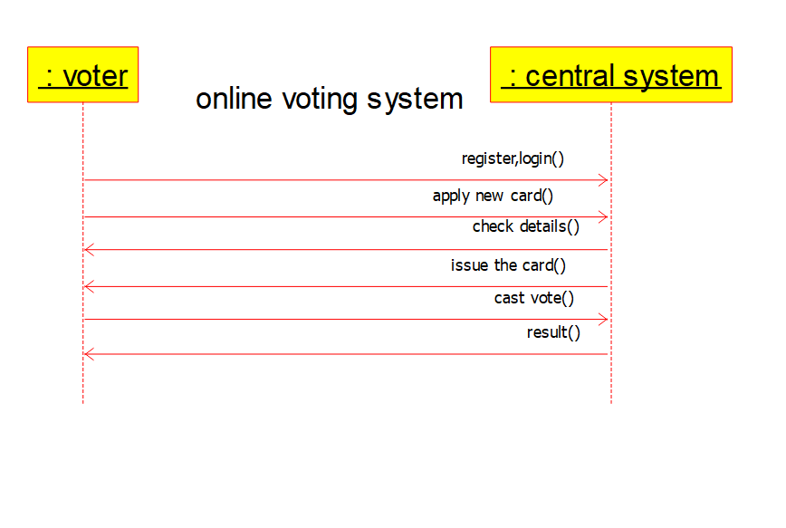

**COMPONENT DIAGRAM:**

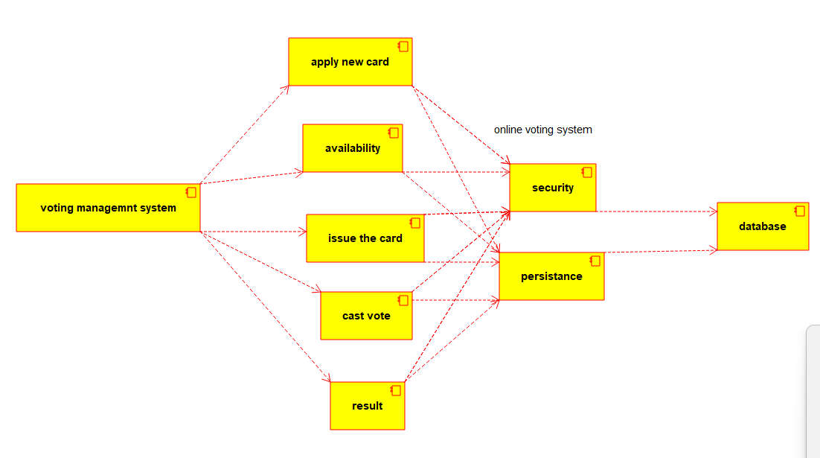

**COLLABORATION DIAGRAM:**

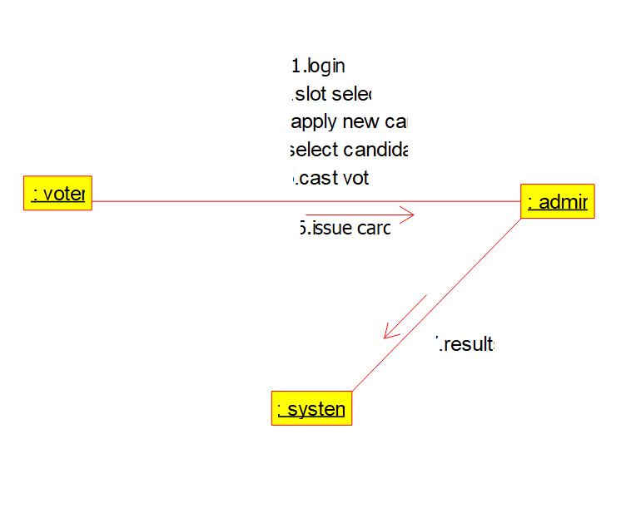

**DEPLOYMENT DIAGRAM:**

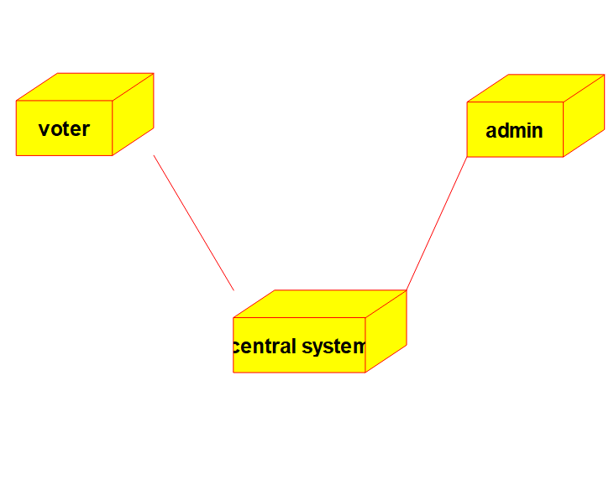

**STATE DIAGRAM:**

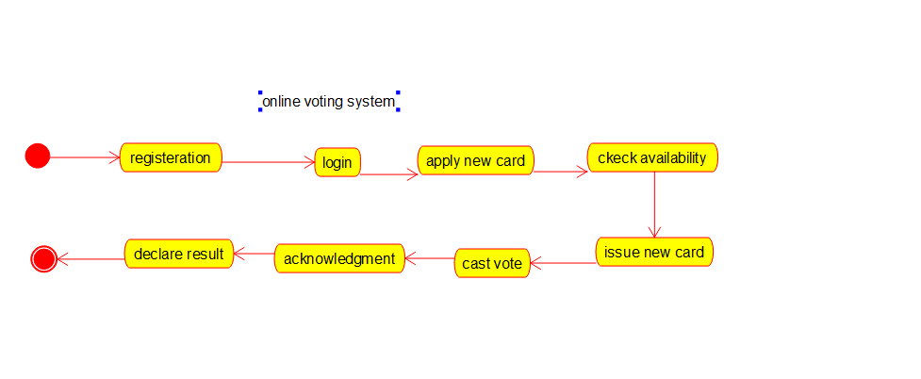

**ER DIAGRAM:**

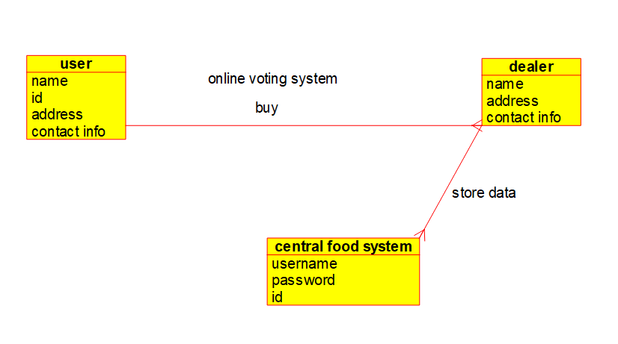

**3.Develop a system using UML for Supermarket Management System. The system should maintain the stock detail, employee detail, and customer details. The system should intimate the product with low stock and nearing the expiry date. The loyalty feature of the customers should be maintained. The offers to the customers should be based on their loyalty features.**

**USE CASE DIAGRAM:**

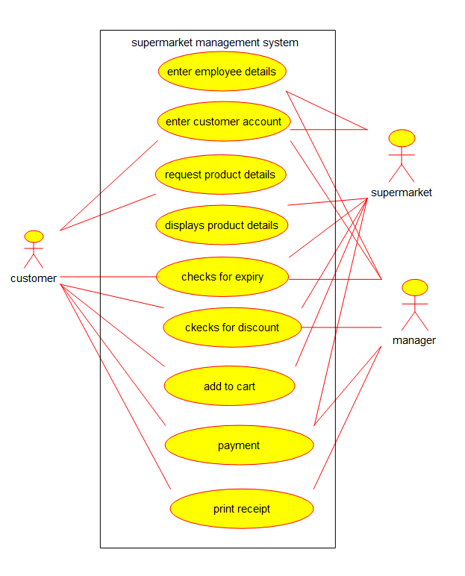

**CLASS DIAGRAM:**

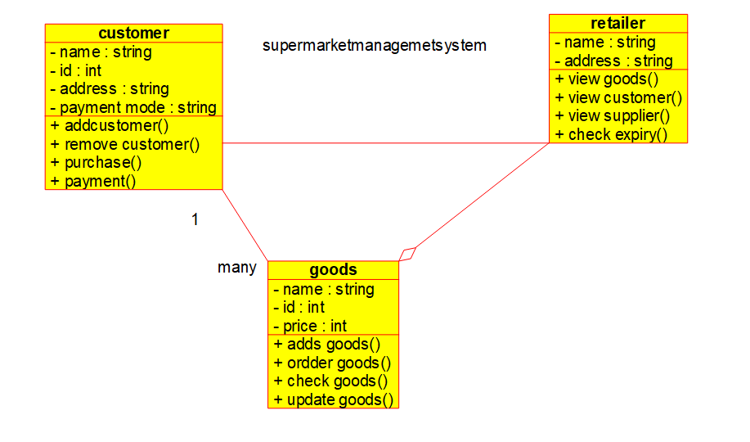

**ACTIVITY DIAGRAM:**

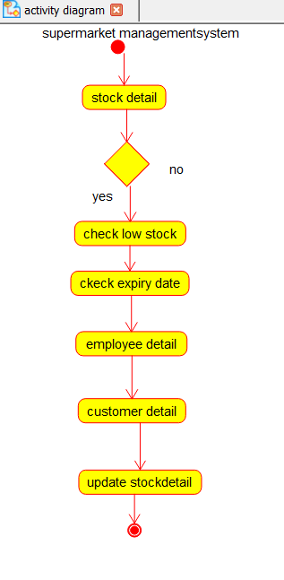

**SEQUENCE DIAGRAM:**

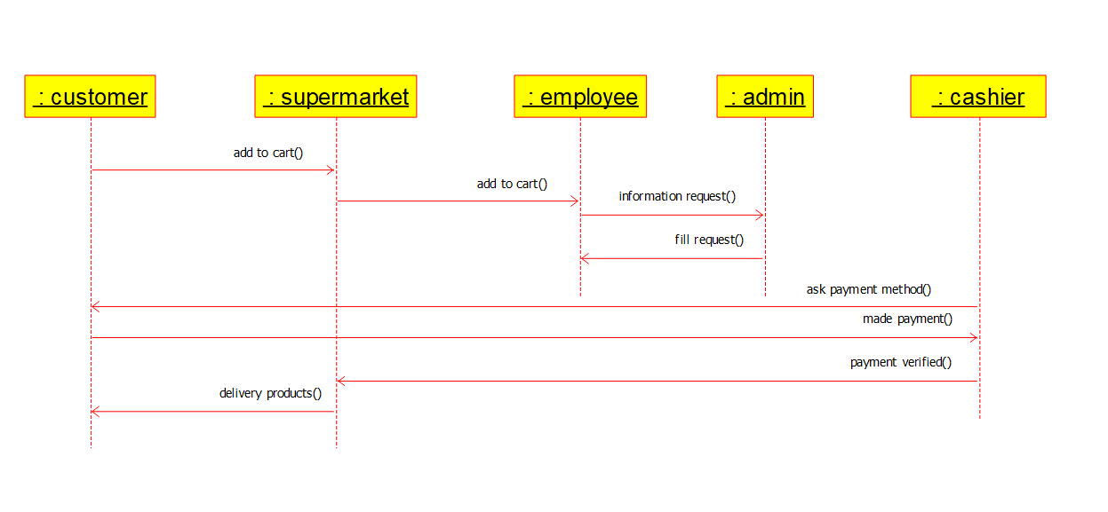

**COMPONENT DIAGRAM:**

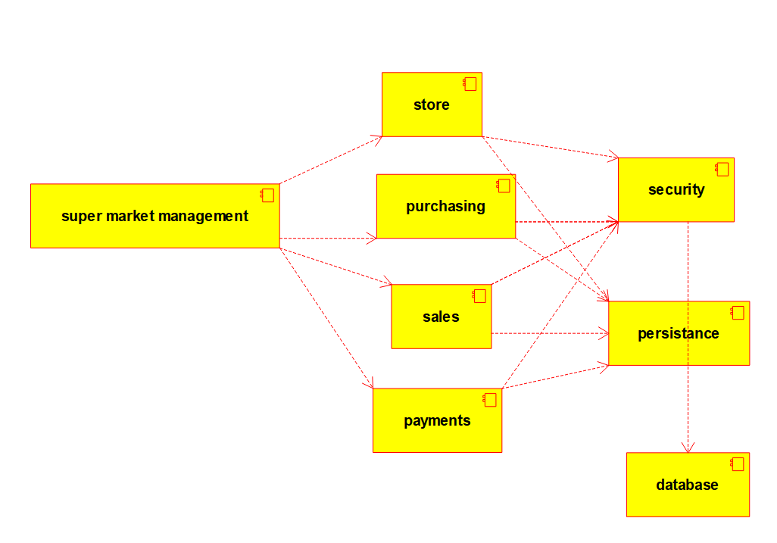

**COLLABORATION DIAGRAM:**

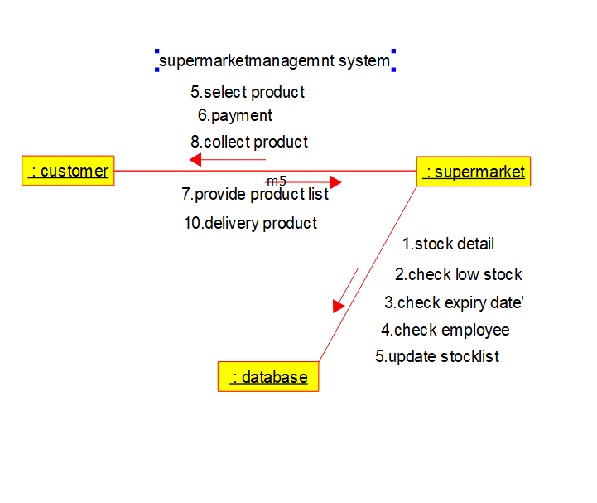

**DEPLOYMENT DIAGRAM:**

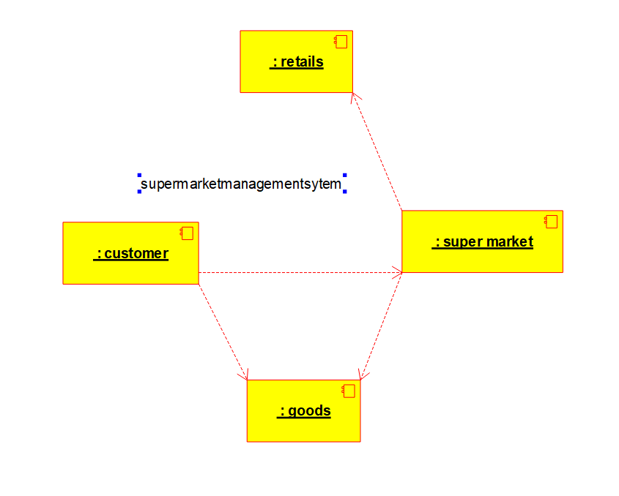

**STATE DIAGRAM:**

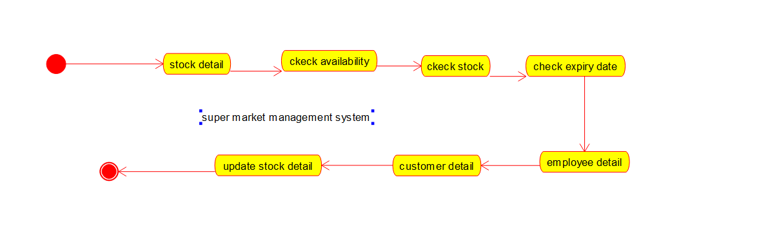

**ER DIAGRAM:**

